# CIS7 Unit 8 Chapter 11 Notes: Sequences, Sums and Series

## Sequences

**A sequence** is an enumerated collection of objects in which **repetitions are allowed**. Like a set, it contains members (also called **elements, or terms**). The number of elements (possibly infinite) is called **the length of the sequence**.

Unlike a set, the **same elements can appear multiple times at different positions in a sequence**, and **order matters**. Formally, a sequence can be defined as a function whose domain is either the set of the natural numbers (for infinite sequences) or the set of the first n natural numbers (for a sequence of finite length n).

A **sequence** is a special type of function in which the **domain is a consecutive set of integers**.

For example, a sequence can be defined to denote a student's GPA for each of the four years the student attended college. The **domain of the function** is {1, 2, 3, 4} for each of the four years.

**A sequence is a function *t* from a subset of the integers** (usually N or Z+) to a set S. Set S will be a set of numbers but we could have a sequence of colors, musical notes, or even computer programs.

We often write **an = t(n).** Each **an** is a term of the sequence. The sequence a1, a2, a3, . . . may be denoted by {an} or {an}n=1···∞. The numbers, 1, 2, 3, . . . are the term indices and a1, a2, a3, . . . are the term values.

### Example 11.1:

**1/1, 1/2, 1/3, 1/4, 1/5, 1/6, . . .**

If n = 1, 1/1 is the first term

If n = 2, ½ is the second term

If n = 3, 1/3 is the third term…

***Next term after 6th term, 7th term = 1/7, t(n) = 1/n.***

***100th term = 1/100***

### Example 11.2

**2, 4, 6, 8, 10, 12, . . .**

If n = 1, 2 * 1 = 2

If n = 2, 2 * 2 = 4

If n = 3, 2 * 3 = 6

If n = 22, 2 * 22 = 44

***Next term after 6th term = 14, t(n) = 2n***

### Example 11.3

**2, 4, 8, 16, 32, 64, . . .**

If n = 1, 21 = 2

If n = 2, 22 = 4

If n = 3, 23 = 8…

***Next term after the 6th term = 128, t(n) = 2n***

### Example 11.4

**7, 8, 9, 10, 11, 12, . . .**

If n = 1, 1 + 6 = 7

If n = 2, 2 + 6 = 8

If n = 3, 3 + 6 = 9…

***Next term after 6th term is = 13, t(n) = n + 6***.

### Example 11.5

**1/2, 1, 2, 4, 8, 16, . . .**

If n = 1, 2(1– 2) = 2-1 = ½

If n = 2, 2(2-2) = 20 = 1

If n = 3, 2(3-2) = 21 = 2…

***Next term after the 6th term = 32, t(n) = 2n−2***

### Example 11.6

**1, 3, 6, 10, 15, 21, . . .**

If n = 1, (12 + 1)/2 = 2/2 = 1

If n = 2, (22 + 2)/2 = 6/2 = 3

If n = 3, (32 + 3)/2 = 12/2 = 6…

***Next term after the 6th term = 28, t(n) = (n2 + n)/2.***

### Example 11.7

**1, 1, 1, 1, 1, 1, 1, . . .**

If n = 1, 1/1 = 1

If n = 2, 2/2 = 1

If n = 3, 3/3 = 1

***Next term after the 6th term = 1, t(n) = n/n or 1.***

### Example 11.8

**1, 1, 2, 3, 5, 8, . . .**

Given 1.

If n = 1, then t(n) = 1

If n = 2, t(n) = 2

If n = 3, t(n) = (3-1) + (3 – 2) = 2 + 1 = 3

***Next term after 6th term = 11, t(n) = (7-1) + (7-2) = 11***

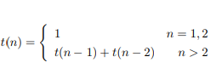

### Example 11.9

**1/2, −2/3, 3/4, −4/5, 5/6, −6/7, . . .**

***Next term = 7/8, t(n) = (−1)(n−1)n/(n + 1)***

### Example 11.10

2, 3, 5, 7, 11, 13, . . .

***Next term = 17, t(n) = nth prime number.***

## Arithmetic Sequence

An **arithmetic sequence** is a sequence in which **each term equals the preceding term plus a constant**.

In an **arithmetic sequence**, the **difference between consecutive terms is always the same**.

**Arithmetic Sequences** are sometimes called **Arithmetic Progressions**

A general arithmetic sequence looks like this **a, a + d, a + 2d, a + 3d**, . . .. The first term is a and the constant difference between terms is d. The nth term of the sequence a, a + d, a + 2d, a + 3d, . . . is given by **t(n) = a + (n − 1)d**.d = distance, difference from one value to the next.

### Example 11.11

**4, 7, 10, 13, 16, 19, . . . a = 4, d = 3,**

***Next term = 22, t(n) = 4 + 3(n − 1) = 3n + 1.***

***7th term = 3 *7 + 1 = 22***

### Example 11.12

**−7, −1, 5, 11, 17, 23, . . . a = −7, d = 6,**

***Next term = 29, t(n) = −7 + 6(n − 1) = 6n – 13***

***7th term = (6*7) – 13 = 29***

### Example 11.13

**30, 25, 20, 15, 10, 5, . . . a = 30, d = −5,**

***Next term = 0, t(n) = 30 − 5(n − 1) = −5n + 35***

## Geometric Sequences

In a **Geometric Sequence** each term is found by **multiplying the previous term by a constant.**

A **geometric progression**, also known as a **geometric sequence**, is a sequence of numbers where each term after the first is found by **multiplying the previous one by a fixed**, **non-zero number called the common ratio**.

A **geometric sequence** is a sequence in which each term equals the **preceding term times a constant**. A general geometric sequence looks like this a, ar, ar2, ar3, ar4, . . . the first term is a and the constant ratio between successive terms is r. The nth term of the sequence a, ar, ar2, ar3, ar4 , . . . is given by

**t(n) = a · r(n−1).**

Example 11.14

**2, 6, 18, 54, 162, . . . a = 2, r = 3,**

***next term = 486, t(n) = 2 · 3(n−1)***

### Example 11.15

1, −4, 16, −64, 256, . . . a = 1, r = −4,

***next term = −1024, t(n) =1* (−4)(n−1)***

## Quadratic Sequences

A quadratic sequence is a sequence whose nth term is given by a quadratic function,

**an = an2 + bn + c**

### Example 11.16

**1, 4, 9, 16, 25, 36, . . .**

an = n2

### Example 11.17

**6, 15, 28, 45, 66, 91,…**

an = 2n2 + 3n + 1

An **arithmetic sequence** is given by **a linear function** and the **difference between successive terms is a constant**.

In a **quadratic sequence,** the **differences between successive terms are given by a linear function** and the **second differences are constant.**

### Example 11.18

Example 11.18: sequence 6, 15, 28, 45, 66, 91...
differences: 9, 13, 17, 21, 25...
second differences = 4 for between two terms.

You can check whether a sequence of number can be given by a **quadratic function by finding the** **second differences**. Once you know that a sequence is quadratic, to find the coefficients a, b, and c, **plug in the values you have and solve for a, b, and c**. The system of three equations in three unknowns that you get will be particularly easy to solve. The method shown in the example below should always work.

For the sequence 6, 15, 28, 45, 66, 91, . . .,

**an = an2 + bn + c**

1. n = 1, a · 12 + b · 1 + c = **a + b + c = 6**
2. n = 2, a · 22 + b · 2 + c = **4a + 2b + c = 15**
3. n = 3, a · 32 + b · 3 + c = **9a + 3b + c = 28**

Subtract the first equation from the second and the second from the third to get:

**4a + 2b + c = 15**

* **a + b + c = 6**

**3a + b = 9**

**9a + 3b + c = 28**

* **4a + 2b + c = 15**

**5a + b = 13**

Now subtract the first of these equations from the second to get:

2a = 4 0r a = 2

**5a + b = 13**

* **3a + b = 9**

**2a = 4**

Use the value a = 2

To find b, substitute a = 2 for 3a + b = 9; then 6 + b = 9 so b = 3.

Finally, use the values of a = 2 and b = 3 to find c.

a + b + c = 6

2 + 3 + c = 6 so c = 1

Plug in a, b, c: an = 2n2 + 3n + 1.

## Series and Partial Sums

**A series** is a **sum of the terms of a sequence**. Since **a sequence has infinitely many terms**, **a series is the sum of infinitely many terms**. We often sum **only the first n terms of a sequence**.

The **sum of the first n terms is called the nth partial sum**. The following is a sum of an infinite number of terms.

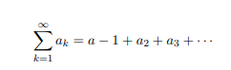

Below is the sum of the first n terms. This is the nth partial sum. k is the index of summation; 1 is the lower limit; n is the upper limit.

Series formula = a(k) is sum of all terms.

This is also a partial sum. j is the index of summation; m is the lower limit; n is the upper limit.

Partial sum formula: each term is added. 

## Arithmetic Sums

An **arithmetic sum** is a **sum of terms of an arithmetic sequence**.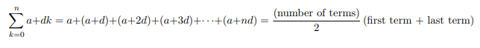

The formula we have given for the sum is easy to remember and does not involve any of the variables, n, a, d. It is based on what we refer to as **Gauss’s Trick**. Carl Friedrich Gauss is considered to be one of the greatest mathematicians to ever live. The story (as my grandfather told it to me) is that at the age of nine, Carl Friedrich Gauss was the youngest student in an arithmetic class. The schoolmaster asked the students to sum up all the numbers (i.e. integers) from 1 to 100. The young Carl immediately placed his slate on the schoolmaster’s table. When all the other students had finished their sums, the slates were turned over and only Carl’s was correct. How did he get the right answer so quickly? Probably he noticed that if you start at the ends and pair up numbers, each pair adds up to 101.

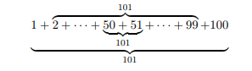

### Example 11.19

1 + 2 + · · · + 100 = (100/2)(1 + 100) = 5050

### Example 11.20

1 + 2 + 3 + · · · + n = n/2(n + 1)

### Example 11.21

2 + 5 + +8 + 11 + 14 + 17 + 20 + 23 + 26 + 29 = (10/2) (2 + 29) = 155

## Geometric Sums and Series

A **geometric sum** is a **sum of terms of a geometric sequence**.

Geometric sum formula: ar^k = all terms added, + ar^n

or, summing from 0

Geometric sum formula: ar^k = all terms added, + ar^n

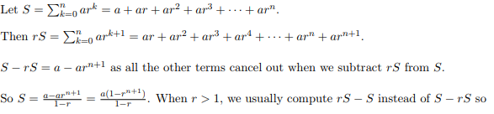

### Example 11.22

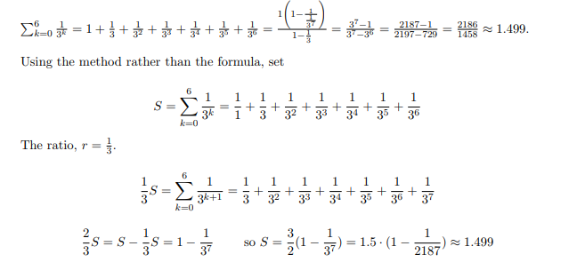

### Example 11.23

Example 11.23: 3^k = 1093

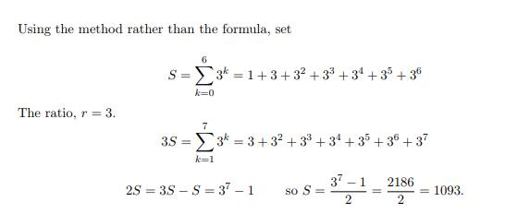

### Example 11.24

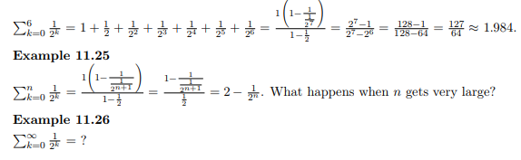

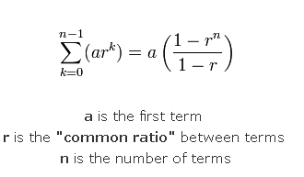

## Some Special Sums

